AD Password Reset

Step1: Open in browser - https://aka.ms/sspr

Step2: Enter username and capcha - Ex: user@comodo.net

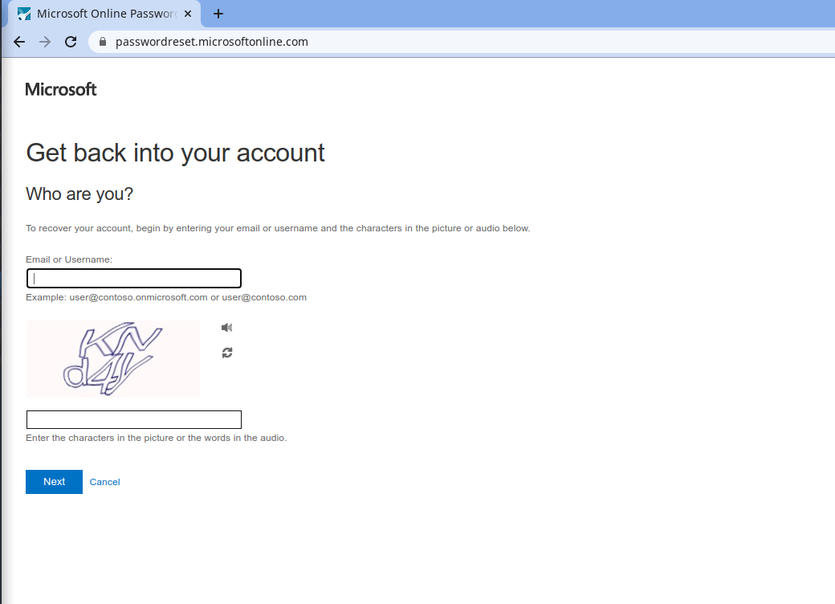

Step3: Forget password

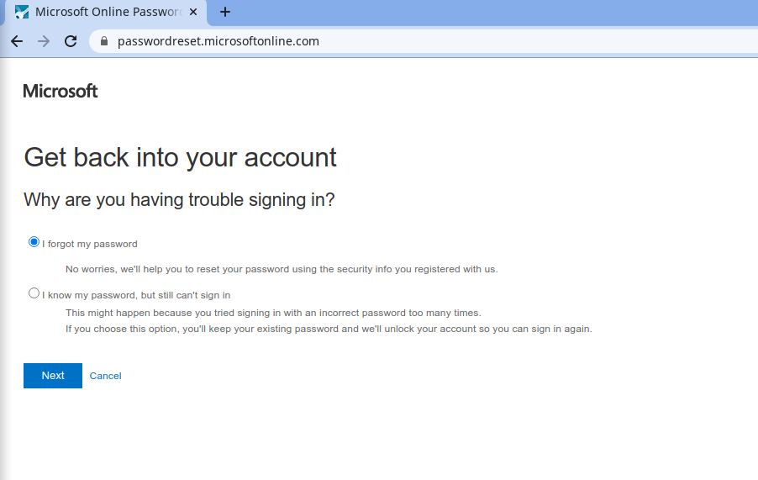

Step4: Choose verification

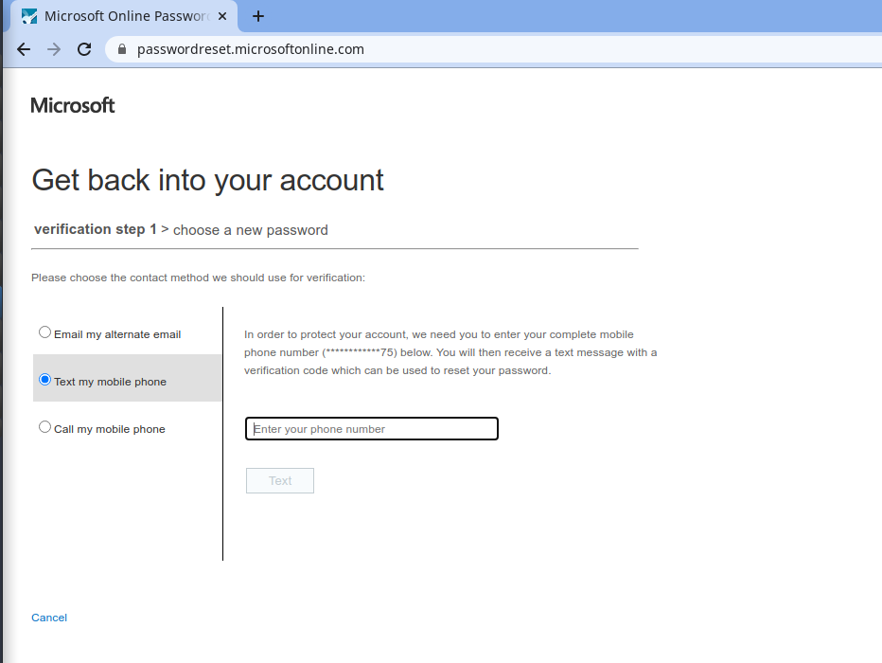

Step: Reset password

